Final Profit/Loss Statement
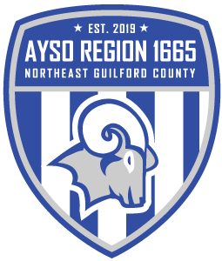

Seed money from AYSO $2000
Sponsorships $2600
Registration Fees $3686
Total $8626
Uniform Costs -$2383
Field Expenses -$3526
Advertising -$ 904
Refunds -$ 107
Office Supplies -$1457
Training -$ 83
Remaining Monies $103

